

**CS-114 - Fundamental of Programing**

**Lab Manual # 6**

**Home Task**

Submitted To: Engr Muhammad Affan

Submitted By: Shahzaib Murtaza (466034)

Section: B

1. Write a program using break or continue statement that only adds prime numbers from 1 to 50 and display the sum on screen.

#include <iostream>

using namespace std;

int main(){

int x, y, z,number;

number = 1;

z = 50;

x = 0;

while (number < z)

{

y = 0;

for (int i = 2; i <= number / 2; i++)

{

if (number % i == 0)

{

y = 1;

break;

}

}

if (y == 0)

{

x = x + number;

}

number++;

}

cout << "Sum of prime numbers from 1 to 50 is : " << x - 1;

return 0;

}

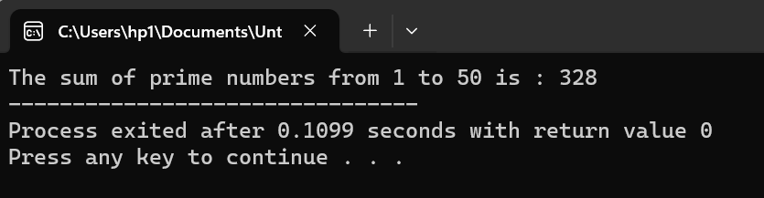

2. Write a program in C++ to create the following pattern.

1

1 2

1 2 3

1 2 3 4

1 2 3 4 5

#include <iostream>

using namespace std;

int main(){

for(int k=1;k<=5;k++)

{

for(int x=1;x<=k;x++)

cout<<x<<"\t";

cout<<endl;

}

return 0;

}

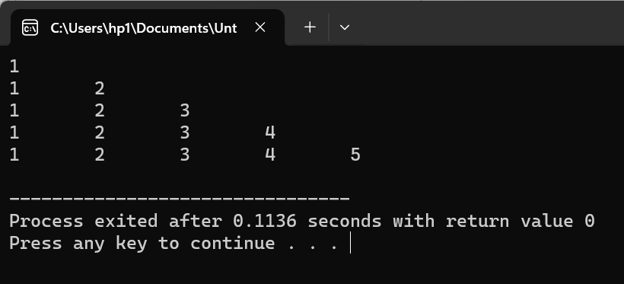

3. Write a C++ program to print:

1

2 2

4 4 4 4

6 6 6 6 6 6

#include <iostream>

using namespace std;

int main(){

int line,a=1;

cout << "Enter the number of lines : ";

cin >> line;

for (int i = 0; i <= line; i++)

{

if (i == 0)

{

cout <<a;

}

for (int j = 1; j <= i; j++)

{

if (i % 2 == 0)

{

cout << i;

}

else

{

continue;

}

}

cout << endl;

}

return 0;

}

